ASSUMPTION UNIVERSITY
VINCENT MARY SCHOOL OF ENGINEERING, SCIENCE AND TECHNOLOGY

MIDTERM 1/2026

SUBJECT: CSX4107 – Web Application Development
LECTURER: Athiphat Hirunadisuan

DATE: Wednesday 7th January 2026
TIME: 9:00 – 11:00 (2 Hours)

Mark Allocations:

This examination is worth 20% of the total semester score and consists of one part:
Part I: | Web application development | 50 points
 | Total | 50 points (20%)

Instructions:
- This exam is open-book and Internet. Students can use their devices, references, and materials, including Internet searches and AI (ChatGPT, GitHub Copilot, etc.).
- Strictly observe plagiarism regulations. Students’ work must be original.
- Students are not allowed to communicate with anyone regarding this examination.
- Follow the detailed instructions in each part carefully.

Name: I.D. No.: Sec.

Examination Regulations
Students are required to strictly observe the following examination rules and regulations while examinations are in the progress. Violating them will subject students to the following terms of punishment: “F” in the concerned subject; suspension from registering for classes in the following term(s) or academic year(s); or Dismissal from the University.

- Do not bring into the examination room/hall the following items unless permission is stated on the examination cover sheet.
• any forms of information, related or unrelated to the examination.
• all types of calculators.
• dictionaries.
Should students turn in the above materials to proctors before attempting their examination, the terms of punishment for cheating cases will not be applied to the students. The materials together with students’ names and admission codes, however will have to be submitted to the Office of Vice President for Student Affairs for official record purpose.
- Do not use all forms of communication devices e.g. smart phones and/or smart watches etc. Should they be brought into examination room, they must be turned off and placed on the floor under students’ desk or chair.
Proctors are required to confiscate and submit the violators’ devices to the Academic Dishonesty Investigation Committee (ADIC) for verification of the allegation. The students’ incompliance with the instruction to surrender the devices would subject the ADIC to assume the validity of the allegation and the terms of punishment regarding cheating and/or violating the examination regulations will be applied to the students accordingly.
The devices can be retrieved directly from the ADIC committee once the allegation is verified.
- Do not place pouches and/or boxes containing writing instruments on the desk. All pouches and/or boxes must be placed on the floor under students’ desk or chair. Only writing instruments e.g. pens, pencils, rulers, and erasers used for examination are allowed to be placed on the desk.
- Do not leave the examination room during the first 30 minutes of the examination regardless of reason. In case there is a need for medical attention during the stated period, students can request proctors to contact “Examination Director” for further assistance.
- Do not visit rest rooms unless the examination is completed, and both answer sheets and question papers are turned in to proctors. In case of emergency, students can request proctors to contact “Examination Director” for further assistance, and they are to be directed to continue their examination in a special examination room.
- Do not leave the examination room without signing their names on the examination list. Violating this regulation so as to claim absence from the examination will subject students to the terms of punishment for cheating cases.
- Do not communicate with other students in the examination room without the proctor’s permission.
- Do not take question papers or any information pertaining to the examination in any form, including students’ answers script outside the exam room. Proctors do not have any authority to give permission for the papers or information to be taken outside.
- Do not loiter around the hallway or the corridor regardless of reasons while examinations are in progress.
- Students must strictly follow the instructions of the proctors and supervisors.

Academic Dishonesty Investigation Committee
August 1, 2018

-Total 4 Pages (Excluding the cover page)-
Part I: Web application development (40 points – 2 hours)

Add features to the Item Management App. The app is built with React.js, which has the following UI.

Application Requirements

Develop a Single-Page Application (SPA) using React for a simple Point of Sale (POS) system.

The application shall allow users to select products, enter purchase amounts, add products to a purchase list, and calculate the total purchase price.

1. Initial Data
- Clone the base code from https://github.com/pop2518hotmailcom/csx4107-2026-01-midterm-basecode.git
- Use React framework with JavaScript only.
- The product and category data have been provided in asset directory and already imported.
- Each product contains information such as:
  - product ID
  - product title
  - category ID
  - selling price
  - discount percentage
  - inventory amount
- Each category contains information such as:
  - category ID
  - category title
  - icon name
- Students shall use the provided data to display and process the application.

2. Category Selection
- The application shall display a category selection list.
- The category list shall include:
  - an option to display all products
  - all categories from the provided category data
- When the user selects a category, the product selection list shall show only products belonging to the selected category.
- When the user selects “All”, the product selection list shall show all products.

3. Product Selection
- The application shall display a product selection list.
- The product list shall be updated according to the selected category.
- When the user changes the selected category, the selected product and purchase amount shall be reset.

4. Purchase Amount
- The application shall allow the user to enter the amount of product to purchase.
- The amount input should be disabled when no product is selected.
- The Add Item button should be disabled when the purchase amount is zero or less.

5. Add Product to Purchase List
- When the user clicks Add Item, the application shall validate the purchase amount.
- The application shall not allow the user to add a product if the purchase amount is greater than the available inventory.
- If the amount is invalid or the inventory is not enough, the application shall display an appropriate error message.

6. Existing Purchased Product
- If the selected product already exists in the purchase list, the application shall update the existing product amount instead of adding a duplicate row.
- For example, if Mouse is already in the purchase list with amount 2, and the user adds Mouse again with amount 3, the purchase list shall show Mouse once with amount 5.
- Also deduct the inventory amount of the product list after purchased.

7. Purchase List Table
- The application shall display the purchased products in a table.
- The table shall show:
  - row number
  - product ID
  - product title
  - product category icon
  - selling price
  - discount percentage
  - purchase amount
  - subtotal price
- The subtotal price shall be calculated from:
  - selling price after discount × purchase amount

8. Grand Total
- The application shall display the grand total of all purchased products.
- The grand total shall be recalculated whenever the purchase list changes.
- The grand total shall include the discounted subtotal of every purchased item.

9. User Interface
- The application layout should be similar to the sample output.
- The exact styling does not need to be identical.
- Students may use any styling method, such as CSS, Tailwind CSS, Bootstrap, or inline styles, as long as the application is clear and usable.

Proof of Work:
- To prevent post-submission cheating, students must sit in the exam room until the end of the exam.
- Students must record their screen with camera open throughout the exam hours even after they have submitted the work.
- Students must submit the recorded session to an explicit assignment. After session ended, it may take few minutes to generate link. Students can submit the link after examination period.
- Fail to submit the recorded session with camera result in 0 mark.

Submission
- Deploy on your GitHub page with base path: /midterm-task-manager-app
Example: https://xxx.github.io/midterm-task-manager-app
- No modification after submission. This can be checked from the publishing date on the GitHub repository.
- Submit 3 links to MS Teams’ Assignment slot, titled Midterm Exam.
  - GitHub Page URL, eg. xxx.github.io/midterm-task-management-app
  - GitHub repository URL of this application code, eg. Github.com/xxx/wad-midterm
  - Link of the Microsoft Teams Recording.

Expected Output
These two elements must be disabled at first

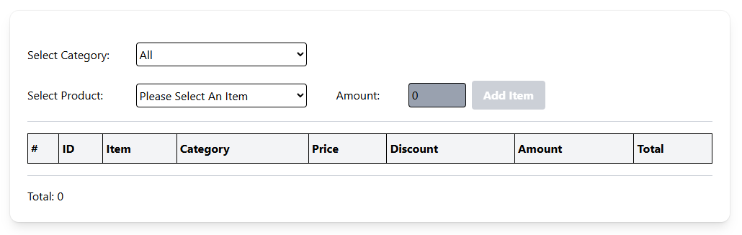
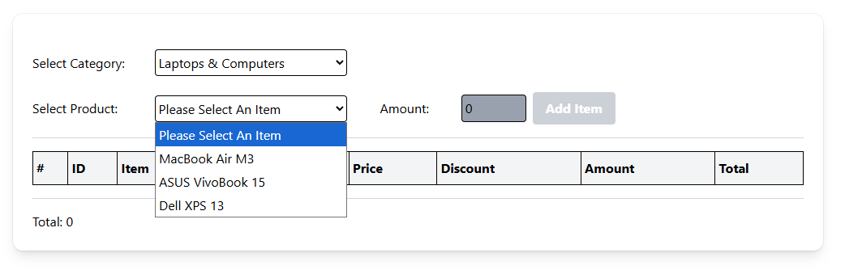
Product must be filtered by category
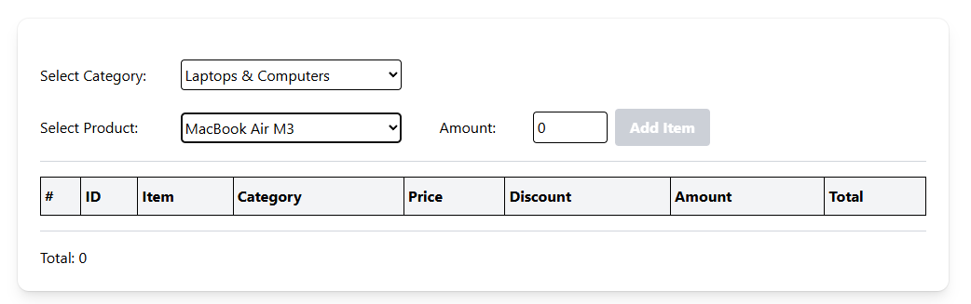
Enabled when a product selected

Enabled when amount is met condition
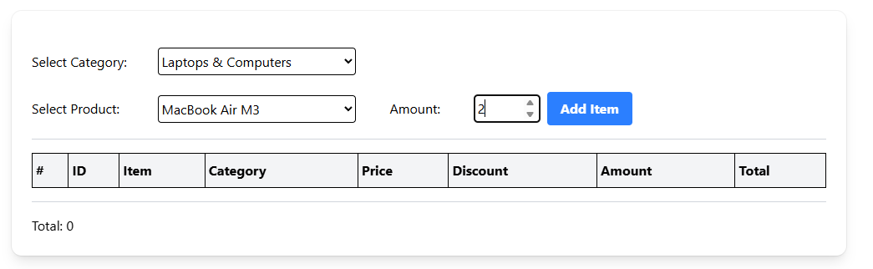

Error message based on condition
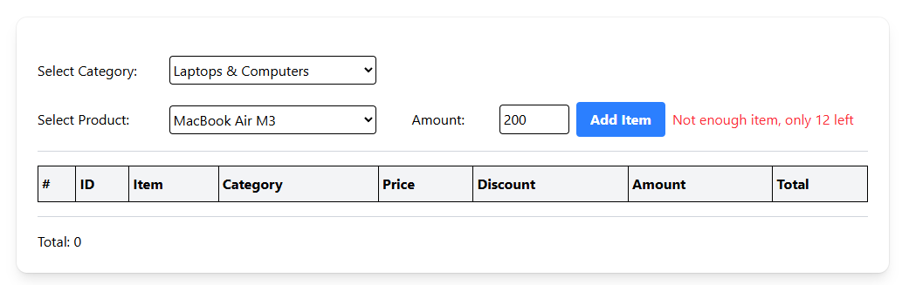

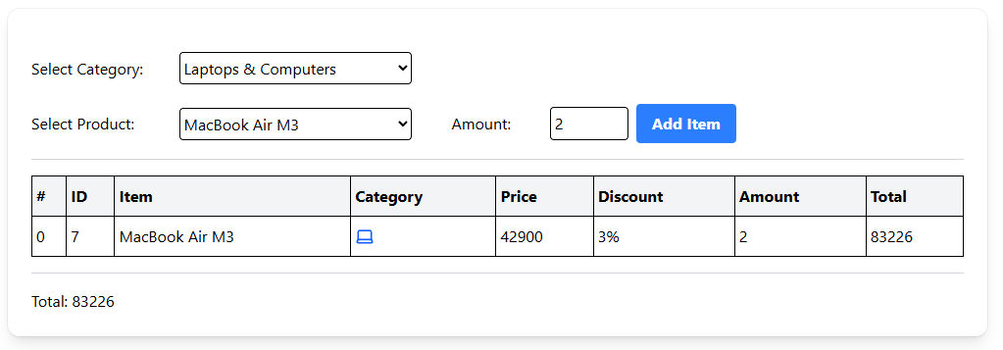

Display purchased items with correct detail, no duplicate purchased items.

Grand total

Grading Criteria:

- [5 marks] Display category list correctly.
- [5 marks] Display product list correctly based on category selected.
- [5 marks] Set disabled/enabled on Amount input field correctly.
- [5 marks] Set disabled/enabled on Add Item button correctly.
- [5 marks] Display error message based on condition correctly.
- [5 marks] Display purchased items in the table correctly.
- [5 marks] Display icon based on product category correctly.
- [5 marks] Calculate and display grand total correctly.
- [5 marks] Show the app on the GitHub Page with the base path: /midterm-pos-app.
- [3 marks] Submit the GitHub Page URL of this app.
NOT THE FIRST PAGE OF YOUR SITE.
Example: https://xxx.github.io/midterm-task-management-app
- [2 marks] Submit the GitHub Repository URL of this work.
Total 50 Points

%%%%%%%%%%%%% End of the Exam Paper %%%%%%%%%%%%%%

